# Identify all the different components you know in the following motherboards.

Number 1

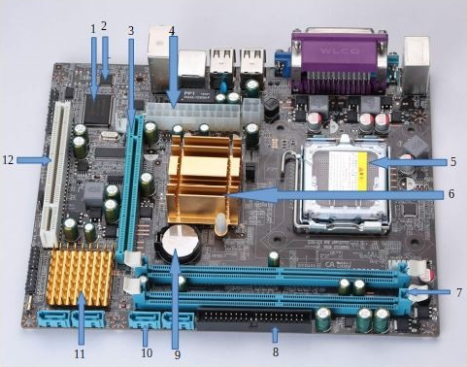

1. Flash memory
2. CMOS
3. PCI Express
4. ATX power connectors
5. CPU socket
6. Northbridge
7. RAM memory slots
8. PATA connector
9. CMOS Backup battery
10. SATA connectors
11. Southbridge
12. PCI

Number 2

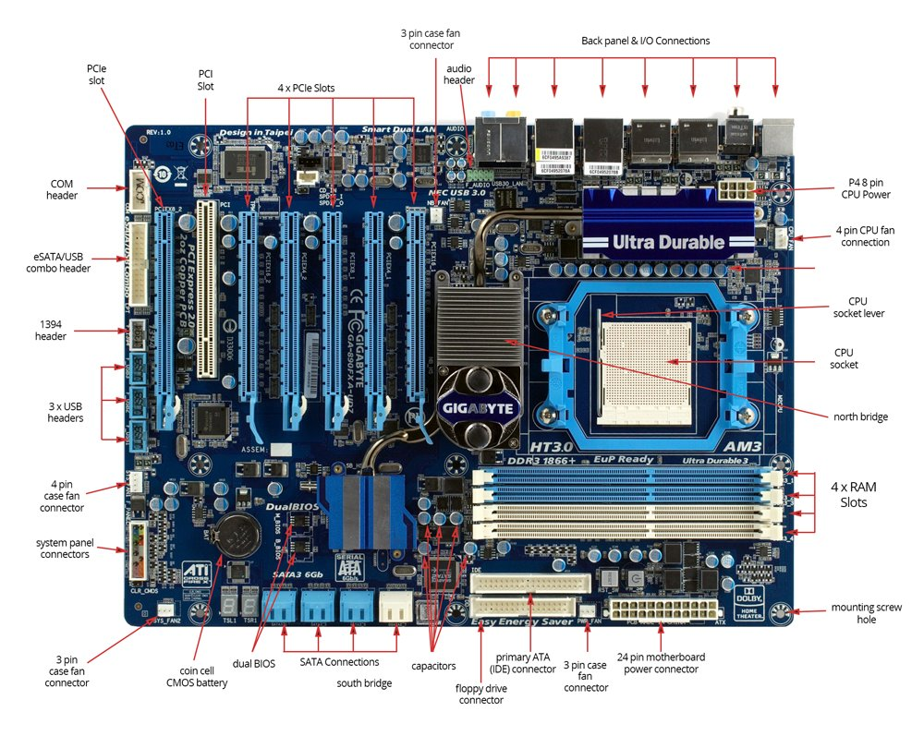

Number 3

1 2 3 4 5

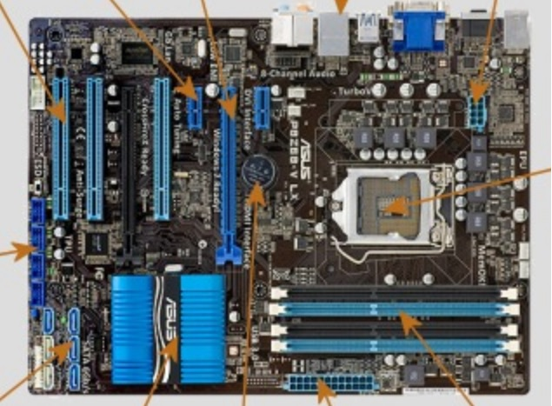

12

6

7 8 9 10 11

1. PCI
2. PCIe x1
3. PCIe x16
4. Rear panel ports
5. 8 pin power
6. USB 2.0
7. SATA connector
8. PCH chipset
9. CMOS battery
10. ATX power 24 pin
11. RAM slot
12. CPU socket

Number 4

Extra ATX

Heatsink

CPU socket

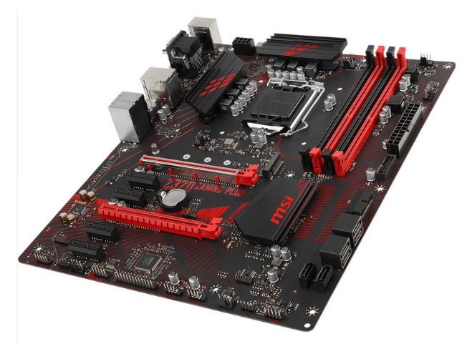

ATX power connector

M.2 SSD port

RAM

SATA ports

Chipset PCH

CMOS battery

PCI express

PCI express

Number 5

PCI express

Mini SATA

PCI e

CMOS

battery

CPU socket

PCI

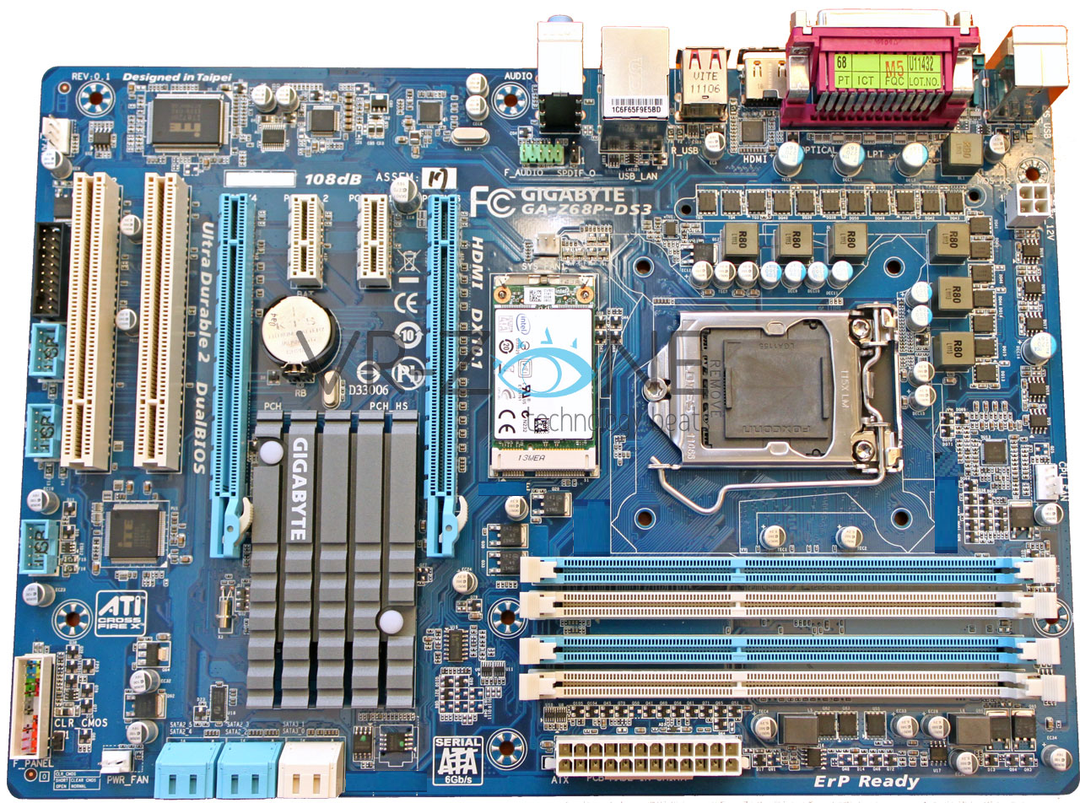

Dual BIOS

FAN connectoro

PCH

RAM slots

ATX 24 pin

Number 6

PCIe

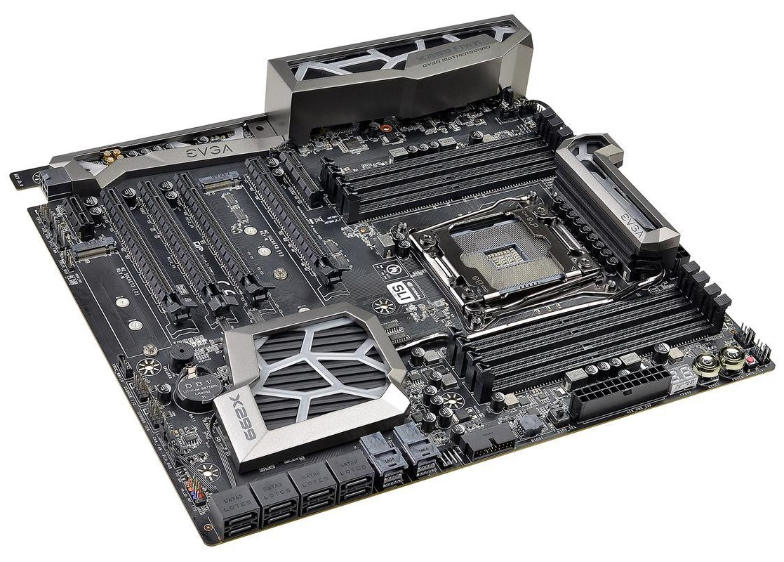

M.2 SSD

CMOS Battery

PCH with

heatsink

U.2

ATX power

connector

Heatsink

PCIe

CPU socket

RAM

SATA port

# Identify the external connectors in the following pictures

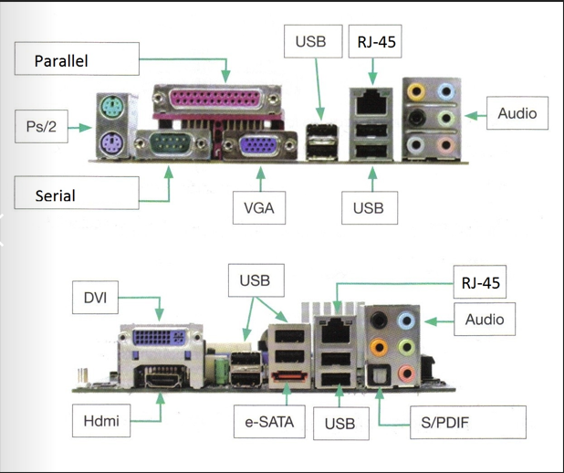

Number 3

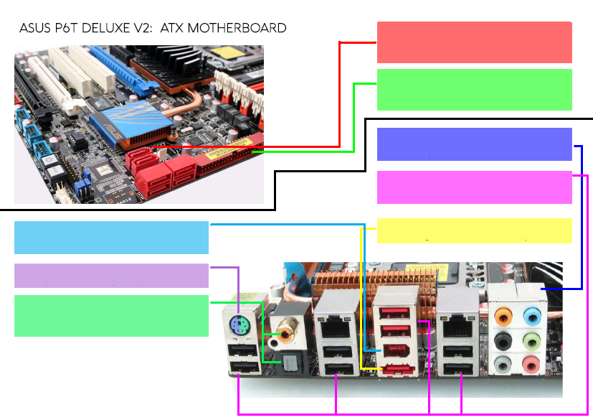

Optical and Coaxial

PS/2 port

Firewire

eSATA port

USB 2.0

Jacks for audio

IDE

SATA 3

Number 4

USB 3.0

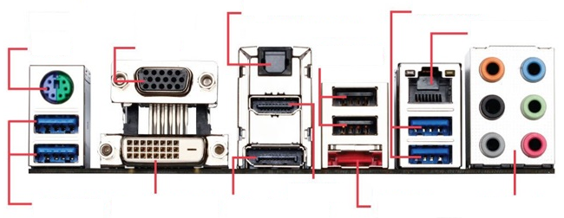

Ethernet

USB 2.0

Optical SPDIF

VGA

HD audio

eSATA

Display port

HDMI

Dual-link DVI

USB 3.0

PS/2